CS241 Processes Part 3 15.10.25
- Interprocess Communication (IPC)
  - Processes running concurrently may want to communicate with each other
  - Examples:
    - Two processes working on same task – may need to share data
    - Data produced by one process may be required by other processes
- Fundamental Models of IPC
  - Two fundamental modules of IPC
    - Shared memory – establish region of memory shared by communicating processes
    - Message passing – messages are exchanged between communicating processes
  - It is the OS's responsibility to provide these communication channels!
- Message Passing vs Shared Memory
  - Message Passing
    - Processes message each other
    - Kernel provides logical communication channel
    - System calls pass messages
  - Shared Memory
    - Processes read/write shared part of memory
    - Kernel only establishes shared memory, then processes use the memory directly
  - 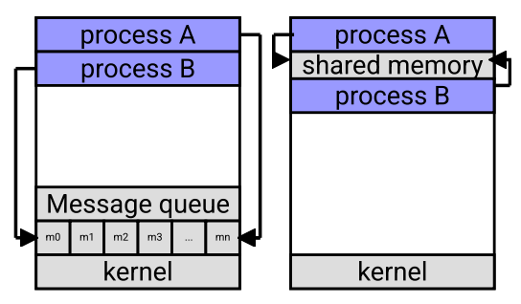
- Shared Memory
  - Resides in the address space of one of the commmunicating processes
  - The other process(es) request permission to access it
  - Kernel is required to setup shared memory and give permissions
  - Once shared memory is established
    - It's up to the user processes for maintaining proper synchronisation
    - e.g., don't write when memory is full
  - 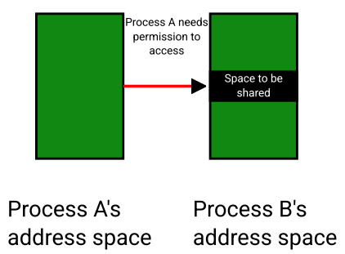
- Producer-Consumer Paradigm
  - Producer – Process that produces information
  - Consumer – Process that consumes the produced information
  - A process can be both a producer and consumer
- Shared Buffer as Circular Queue
  - 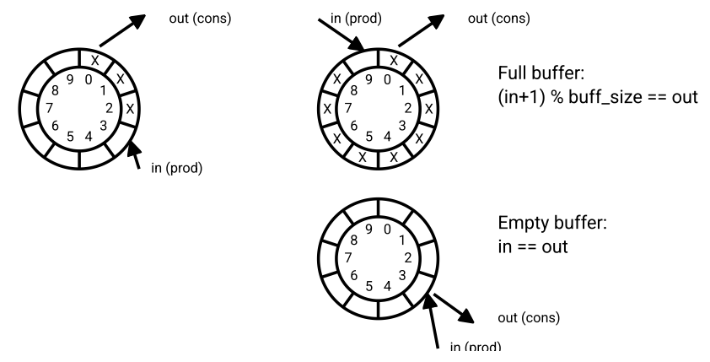
- Shared Buffer Code Example
  - Pseudo Producer
    - 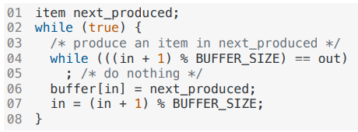
  - Pseudo Consumer
    - 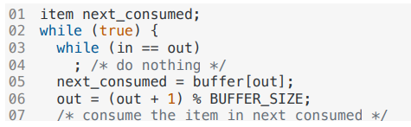
- Message Passing Systems
  - Message passing system provides at least two operations
    - send(message)
    - receive(message)
  - Generally implemented as system calls
  - 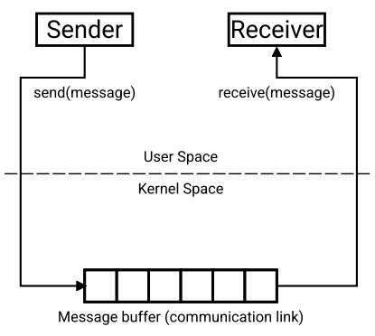
- Implementation of send() and recieve()
  - Implementation depends on
    - Link implementation: Direct or Indirect
    - Synchronisation between send() and receive()
    - Buffer size representing the communication link
  - 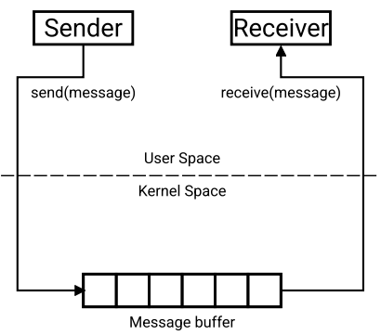
- Direct Communication
  - Processes must name each other explicitly
    - send(P, message)
    - receive(Q, message) or receive(id, message)
  - Properties of communication link
    - Links established automatically
    - Link has exactly one pair of communicating processes
    - Can't hardcode PID, as PIDs can change
  - 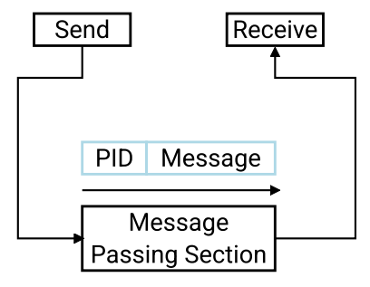
- Indirect Communication
  - Messages are directed and received from mailboxes (also referred to as ports)
    - Each mailbox has a unique ID: send(mailboxID, message), receive(mailboxID, message)
  - Properties of communication link:
    - Established only if processes share a common mailbox
    - Link may have many processes
    - Each pair of processes may share several communication
  - 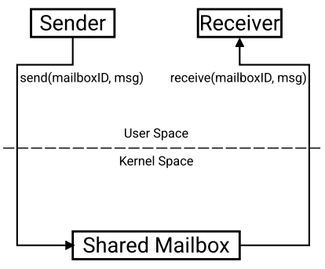
- Synchronisation
  - Blocking is considered synchronous
    - Blocking send: sender blocked until message received
    - Blocking receive: receiver blocked until a message available
  - Non-blocking is considered asynchronous
    - Non-blocking send: sender sends message and continues
    - Non-blocking receive: receiver receives valid message or a null message
  - 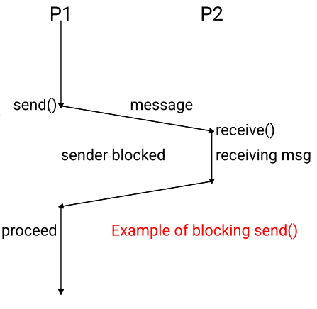
  - Can use different combinations of blocking/non-blocking send/receive
  - e.g., maybe non-blocking send() in combination with a blocking receive()
    - Allows sending process to keep sending without waiting for receiver to process the message
- Buffering
  - Communication link is a buffer.
  - If buffer is:
    - Zero Capacity: Sender must block until recipient receives the message
    - Bounded Capacity: Queue has finite length, so when full sender must block
    - Unbounded Capacity: Queue is potentially infinite, so sender never blocks
- Examples of IPC Systems
  - Some examples:
    - Shared memory using mmap
    - Pipes
    - Named pipes
- Shared Memory Example
  - 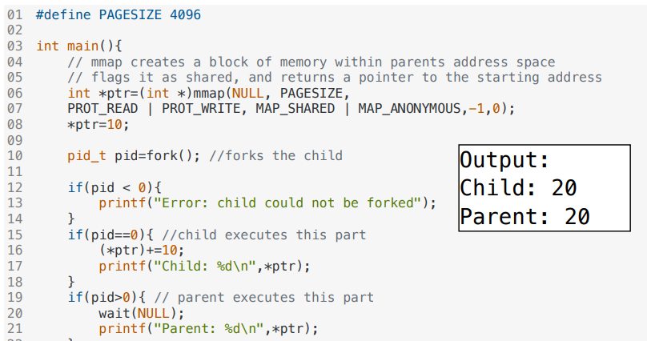
- Ordinary Pipes
  - Ordinary Pipes in UNIX allow simple one-way communication through message passing
  - Pipe connects output of one process to input of another process
  - In UNIX, create pipes using | in bash (or similar shells such as zsh)
  - 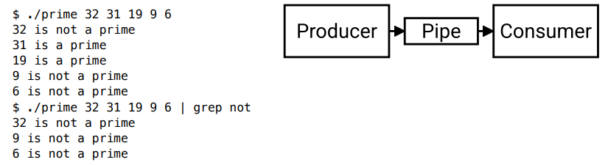
- Example of Ordinary Pipes in C
  - 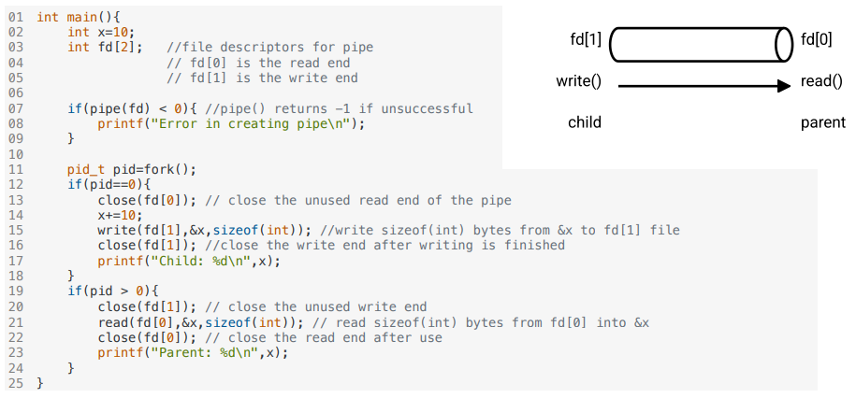
- Named Pipes
  - Ordinary pipes
    - Only exist while the processes are communicated
    - Cease to exist when processes finished
    - Not accessible outside the process which created it
  - Named pipes are much more powerful
    - mkfifo, creates a First-In-First-Out file that multiple processes can communicate with
    - Treat FIFO file like any other file
  - 